CREATION OF EC2 INSTANCE

STEP1:Open the EC2 launch page in Amazon Management console.

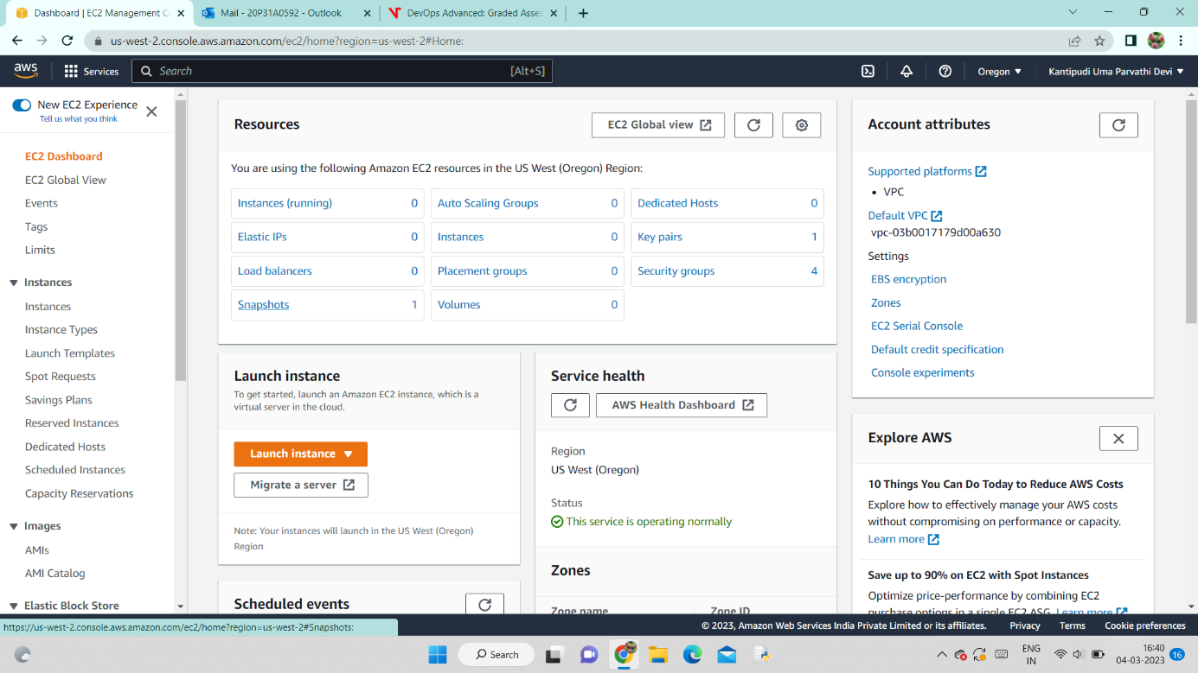

STEP 2: Click on launch instance and then choose “launch instance”. Then specify a name to your ec2 instance. 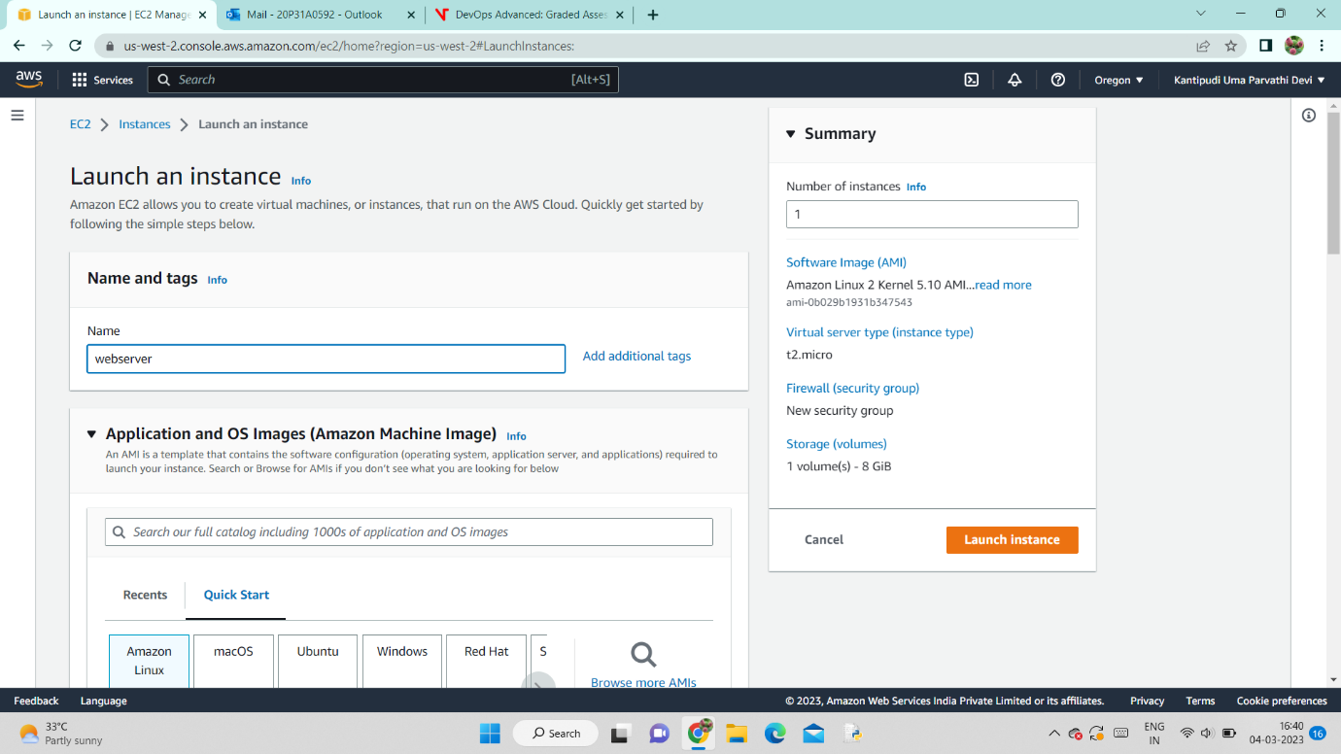

STEP 3: Select your required Amazon Machine Image, here I selected Amazon Linux which is eligible for free tier.

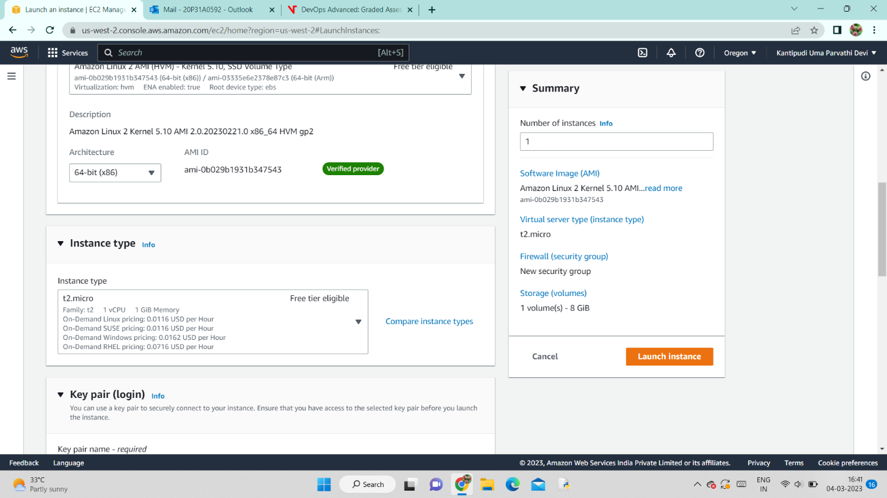

STEP 4 : Select instance type.

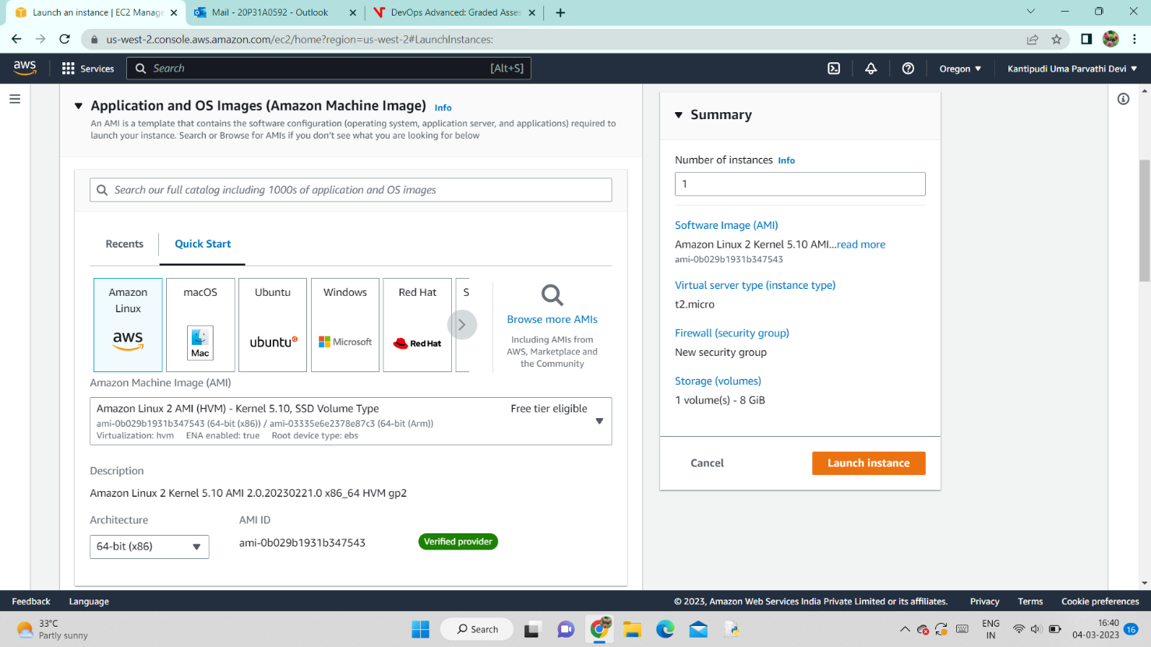

STEP 5 : create a key pair for your instance .If you already have a key pair ,you can also select it instead of creating a new one.

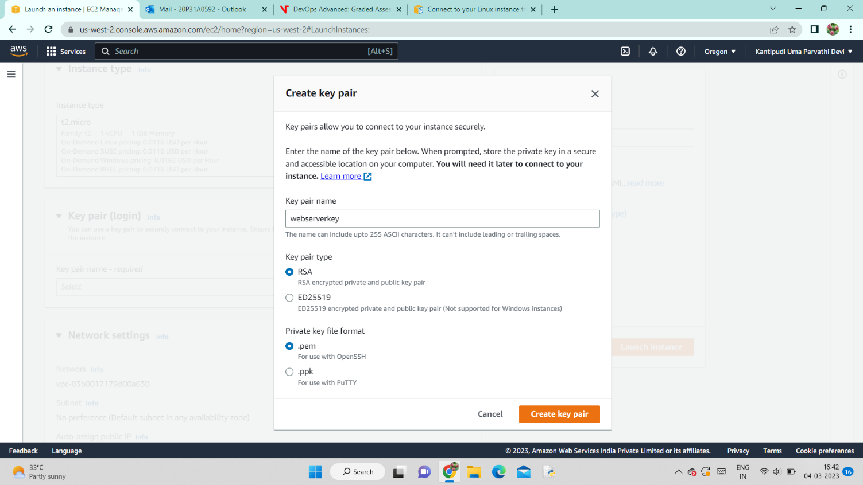

STEP 6: Choose a vpc and subnet for instance.

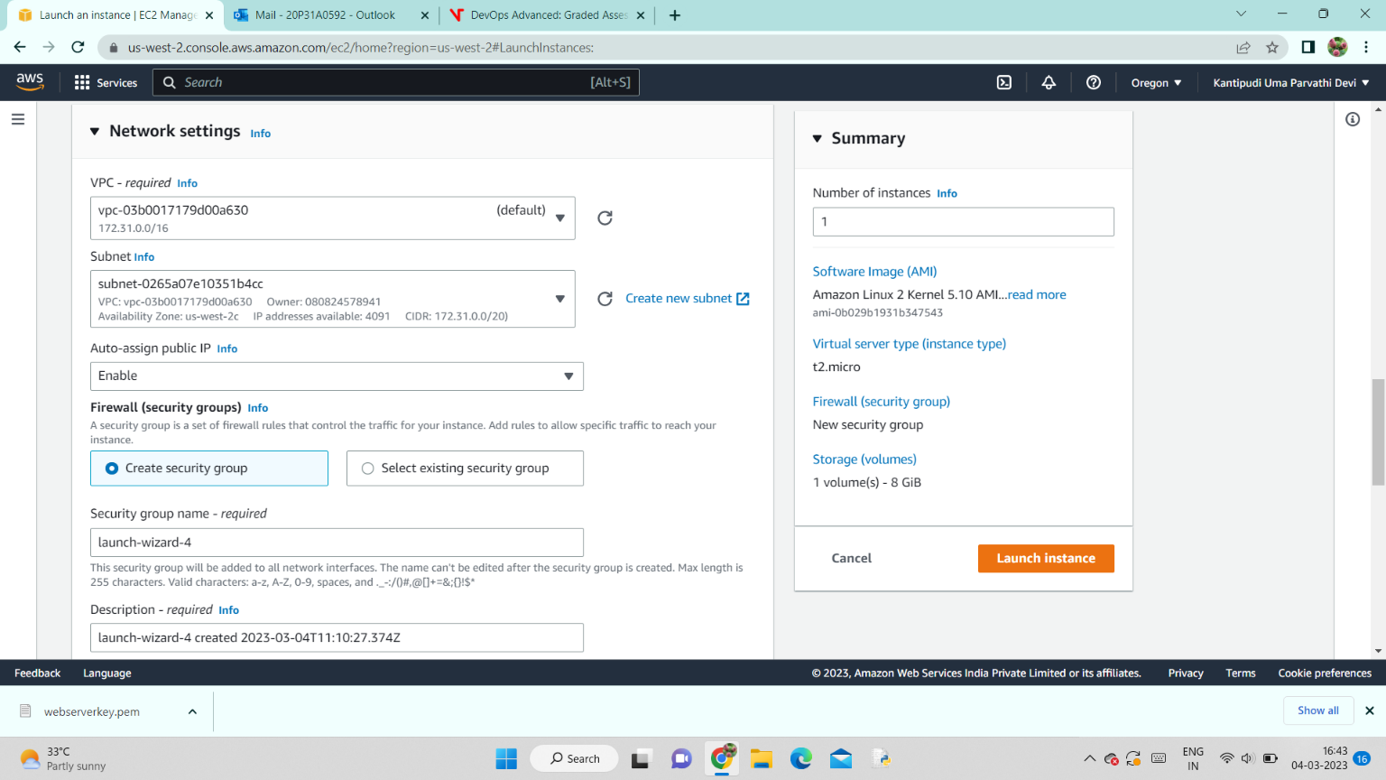

STEP 7 : Select a security group for your instance. If you don’t have one then create a security group with your required traffic ports.

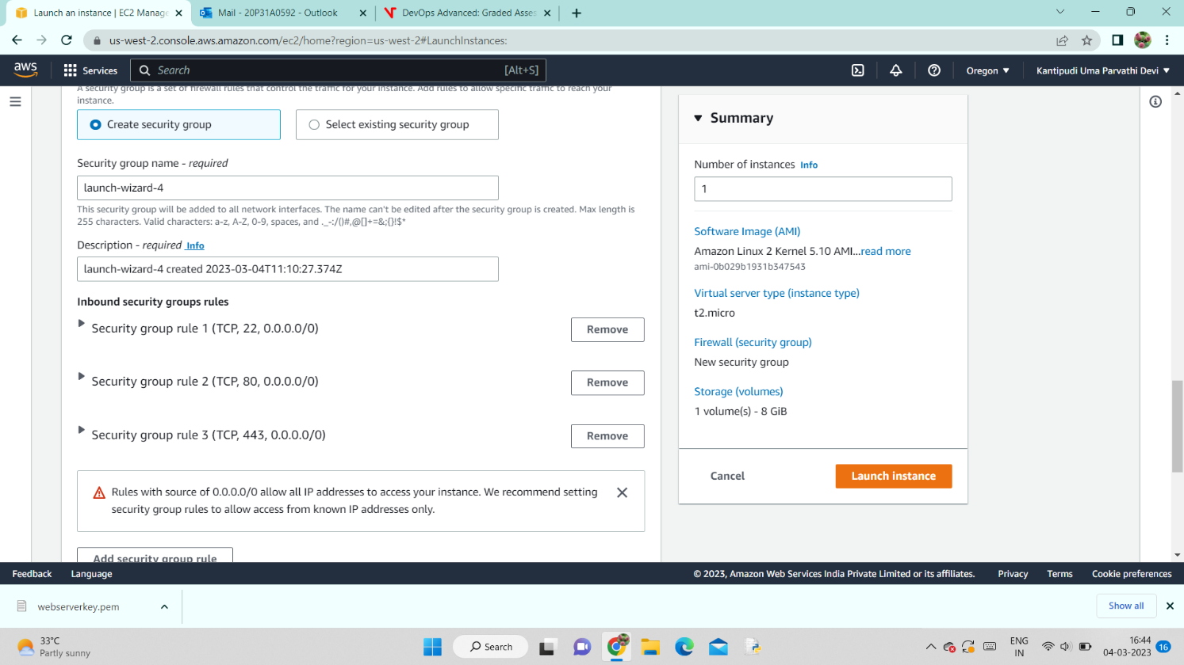

STEP 8 : Configure a Storage needed to your instance.

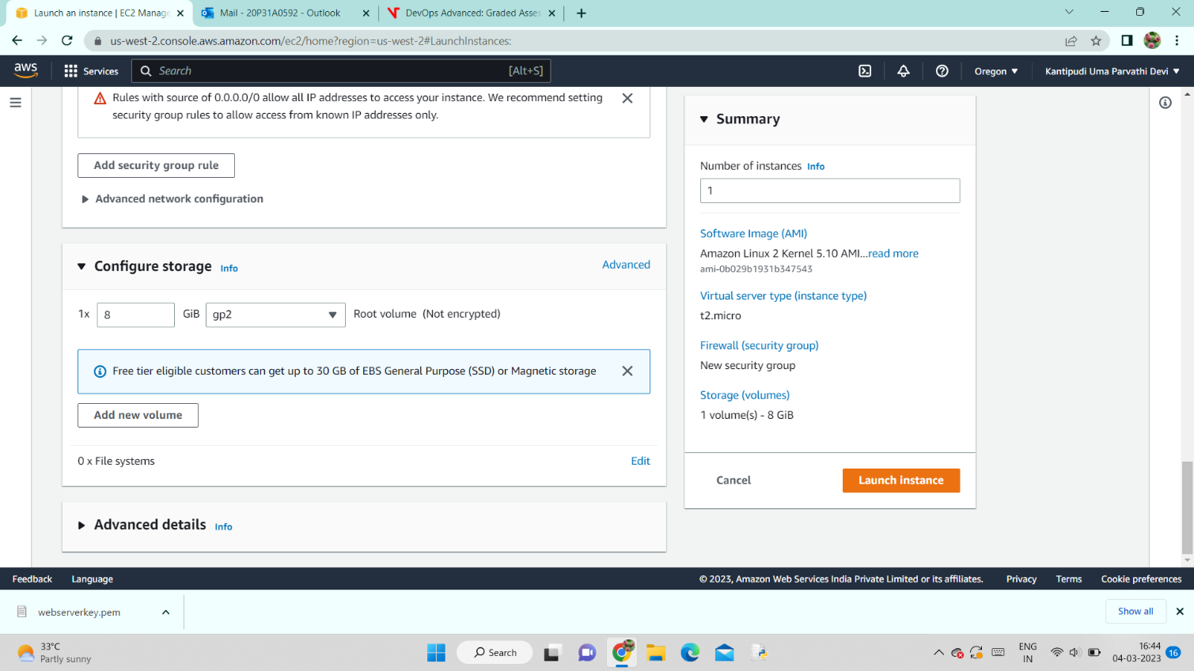

STEP 9 : Here I gave user data in advanced details . You can also give these commands once after you establish a connection with your instance.

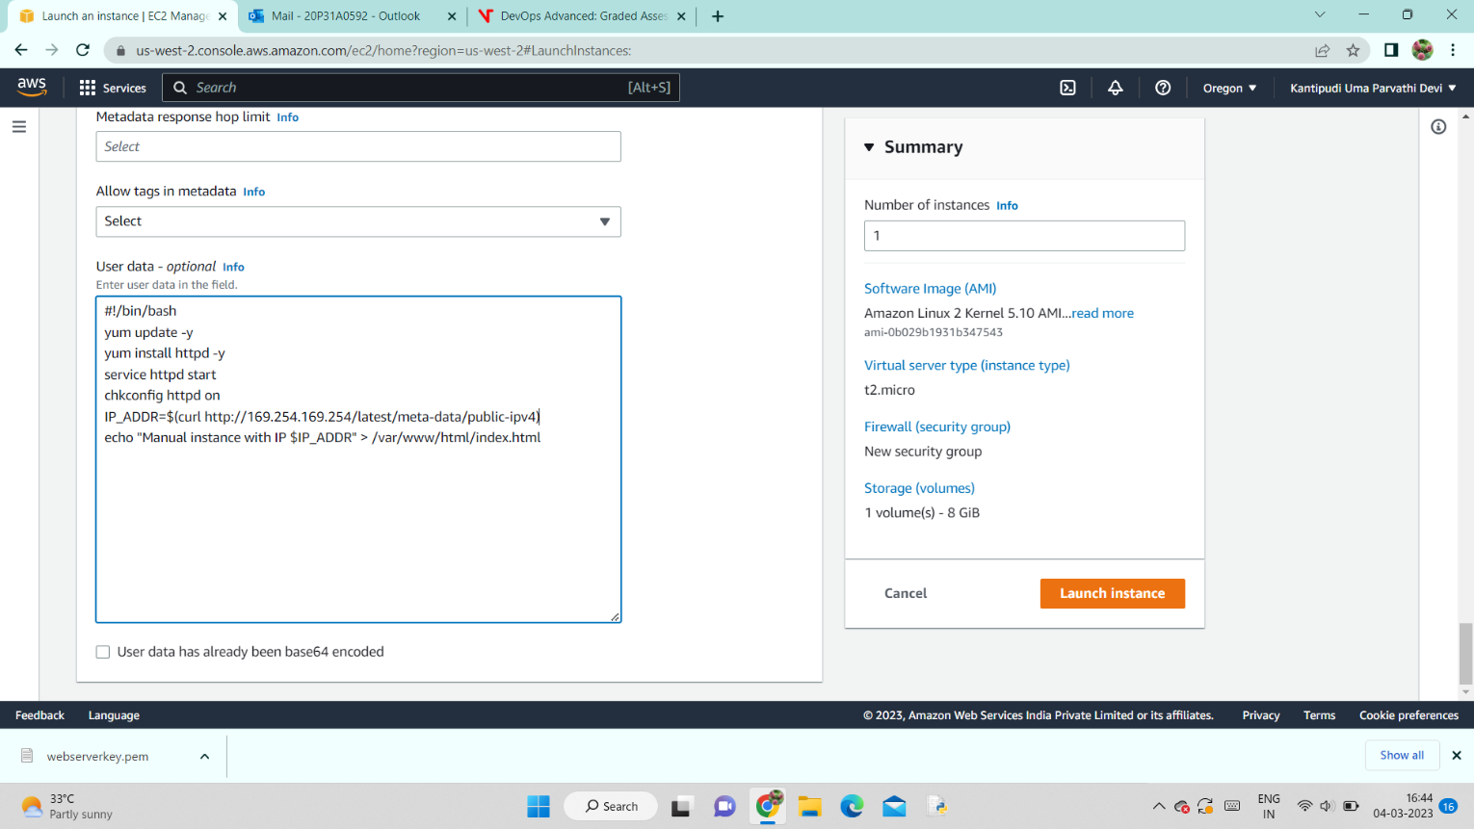

STEP 10 : Click on “Launch Instance”. After you launched your instance you can see log details as in below screenshot.

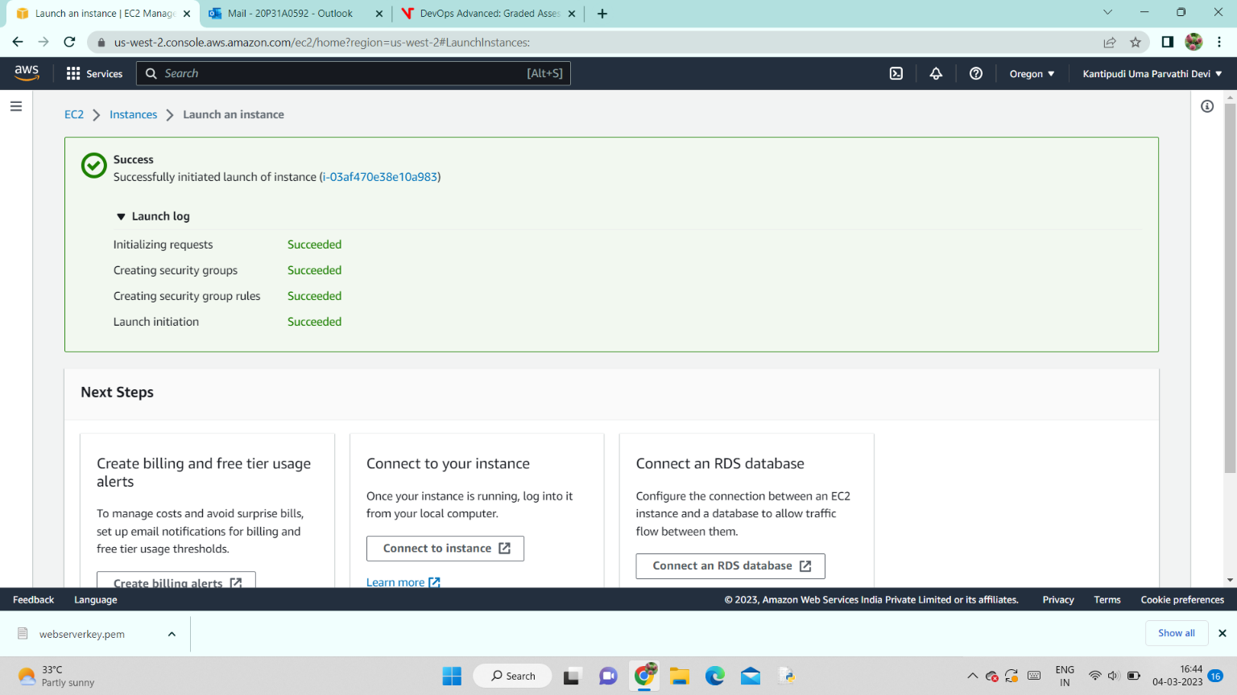

STEP 11 : Now move to instances. With in 1 o 2 minutes you can watch that your instance will come into a running state and having 2/2 checks passed status. Under your instance “details” you can find your instance private and public ipv4 addresses.

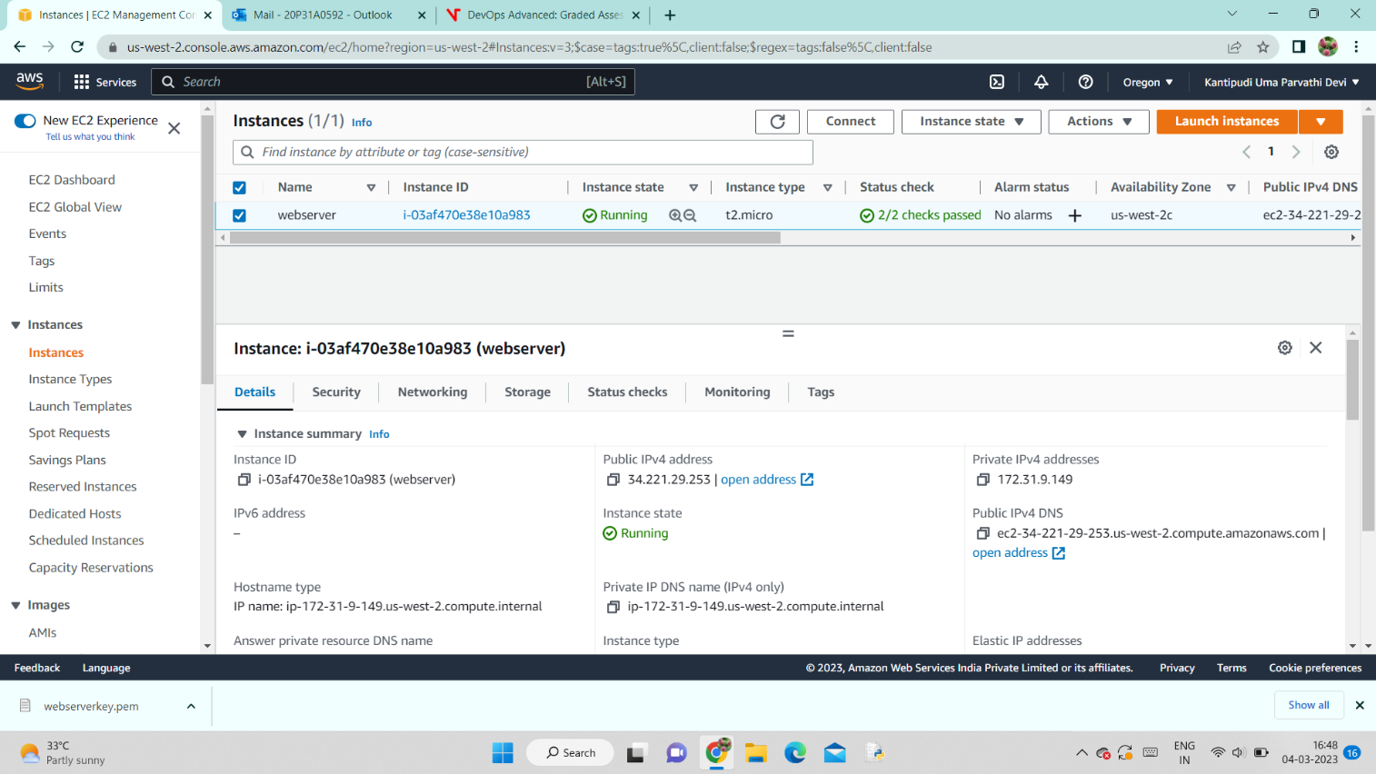

STEP 12 : In “Monitoring” section you can view the percentage of your resources utilization.

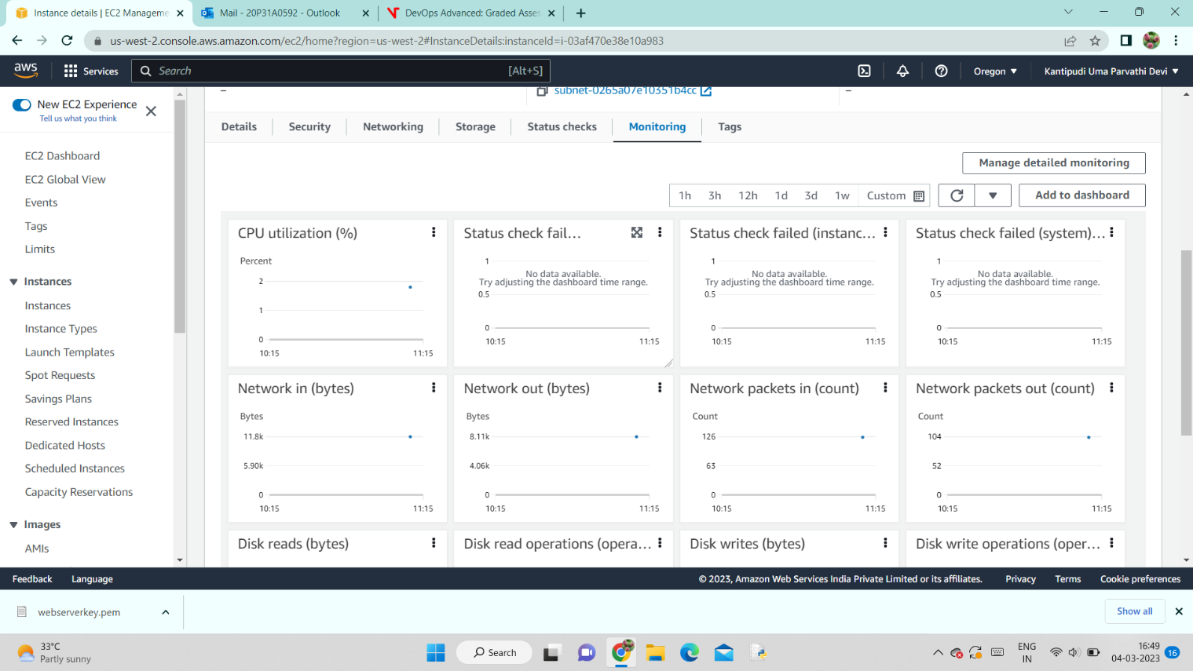

STEP 13 : To connect your ec2 instance to your local system, go to “connect” option in your EC2 instance and then click on “SHH client” . Their you can see SSH command that is used to connect to our instance through your local machine. Now copy that SSH command and paste it in command prompt.

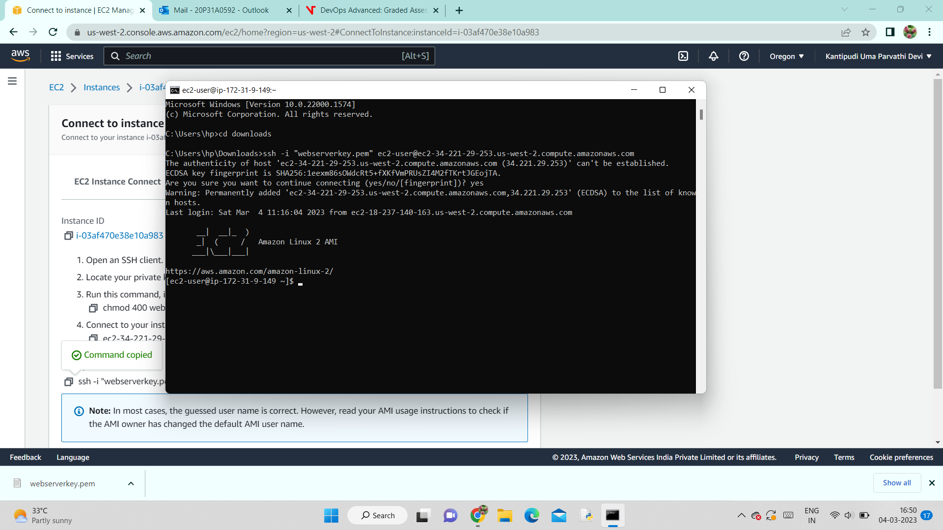

STEP 14: To check whether your instance is working or not paste a public IP of your instance in your local browser. It will show as below if it is working properly.

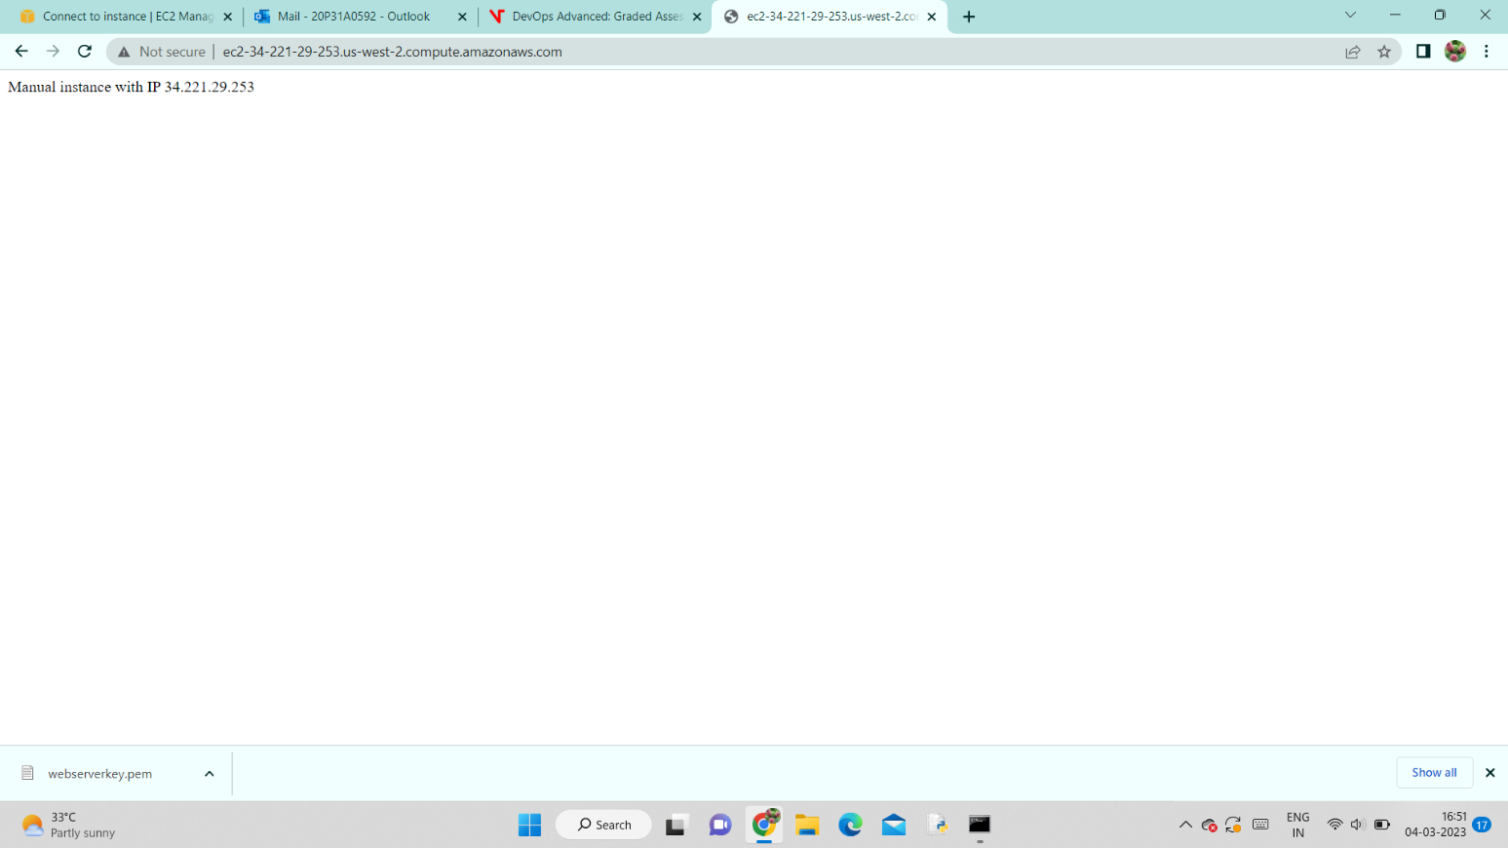

STEP 15 :After completion of your work with our instance, either stop it if you want to resume your work or else terminate it. To terminate your instance go to instance state and then click on “Terminate instance”.

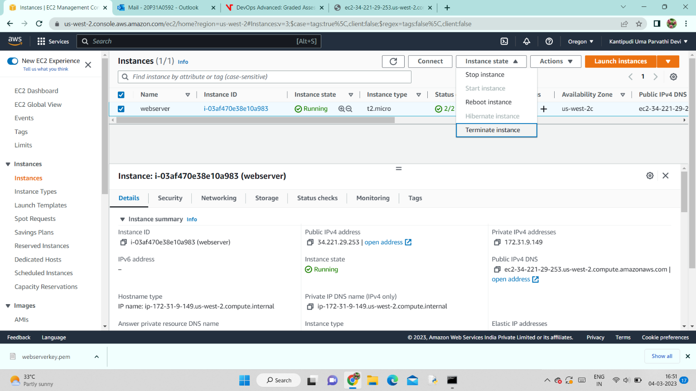

STEP 16 : Click on terminate.

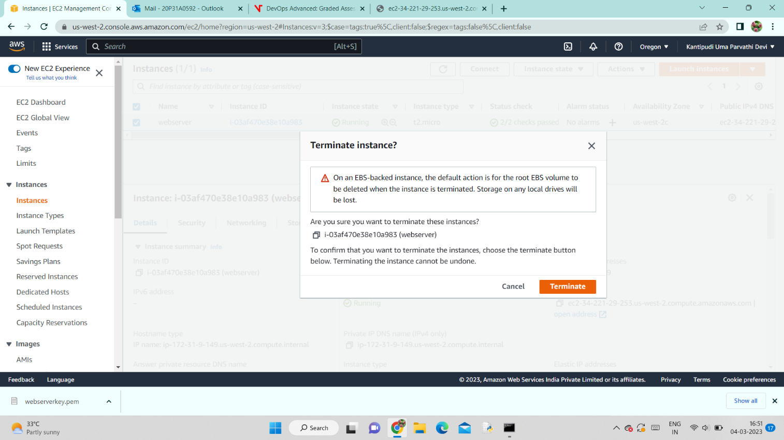

STEP 17 : Your instance will be terminated and will show a pop up message regarding termination.

